TPC3

1.

1. There are two states, one when the princess is at tower A and one when she’s at tower B. State Space:

X = {A, B}

The actions is to invade tower A (Ia), tower B (Ib) and observe the towers (O). Action Space:

A = {Ia, Ib, O}

The observations are to see the princess at tower A, see her at tower B or see nothing. Observation Space:

Z = {A, B, N}

For the following answers the number identifying the row and column, corresponds to the index from the list of the represating Space.

1. The transition probabilities for each action are:

Probability for Ia action:

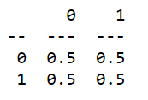

Probability for Ib action:



Probability for O action:

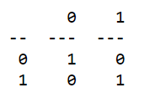

The observation probabilities for each action are:

Observation probability for Ia action:

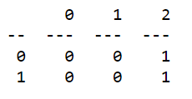

Observation probability for Ib action:



Observation probability for O action:

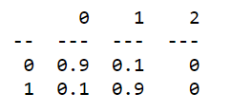

For the cost function we assume that when invading the tower where there’s no princess, we give a maximum cost of 1, a small cost of 0.1 to peer and no cost if the knight invade the tower with the princess in it. Resulting in:

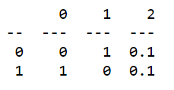

1. To compute the belief we used:

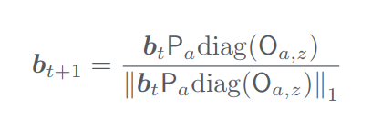

Where bt is the belief that the princess is at tower A ([0.7 , 0.3]), Pa is the transtition probability of the action observe (O), and Oa,z is the selecting the column of observing the princess at tower B from the observation probability matrix for action observe (O).

Resulting in the new belief:



Grupo nº 37

João Silvestre, nº 80996

João Pestana, nº 79515